Future-proof “Black Forest Quality” Made in India
Major extension of the Coimbatore plant in India strengthens the market position and delivery capacities of ZAHORANSKY for the global market

Coimbatore, 12th December 2019. After around a year of construction, the works are finally completed: With the extension of the plant in Coimbatore, India completed, ZAHORANSKY sets course for the sustainable expansion of its business in developing state-of-the-art solutions for toothbrush production in price-sensitive markets. By doubling the production capacities and adding office and meeting spaces, the increasing demand from customers from India, Asia, and Latin America for molds and machines to manufacture toothbrushes can now be met better from the Coimbatore location. “With the completion of the new construction project, we are starting a new chapter for ZAHORANSKY Coimbatore. We will ensure clear optimizations in our future production and logistics processes, and with that shorter delivery times, with additional 3,200 square meters. Moreover, this opens up additional room for our models produced in India, the Z.ORCA, Z.SWORD, and Z.SHARK,” explains Robert Dous, Head of Sales/Marketing of ZAHORANSKY AG. The expansion was accompanied by the optimization of workplaces and processes, to lay the foundation for quicker, more efficient, and more flexible production. Furthermore, programs for employee qualification and motivation make ZAHORANSKY an even more attractive employer.

When the groundbreaking for the expansion of the ZAHORANSKY location took place in October 2018, the Indian subsidiary had already relocated from Mumbai to Coimbatore about ten years prior to this. In the beginning, ZAHORANSKY produced in rented premises, until the highly satisfying development of Asian business allowed for the opening of the company’s own plant in 2013. By now, the Indian branch has developed into the second-largest location of the ZAHORANSKY Group overall, employing around 160 professionals. The constant growth in demand – above all in 2018 and 2019 – from India, as well as China, Indonesia, and South Africa, resulted in the plant reaching the limits of its capacity. Every square inch of space was used at the end, especially in the assembly hall and storage. This situation not only restricted the delivery capacity and flexibility in realizing customer solutions, it also limited the actual growth potential of the location.

More space, greater flexibility
After the expansion of the plant, approx. 6,000 square meters will be available for offices, parts manufacturing, assembly and storage. Additionally, the perfect conditions have been created for order processing and customer care in the existing buildings, with further modern office and meeting rooms. “The expansion allows us to respond to customer requests with even greater flexibility, while simultaneously meeting the growing demand of our customers for a higher degree of automation in the production of their toothbrushes,” explains Dous, further adding, “With these measures, we also ensure that the production in Coimbatore will be able to follow the very strict standards of quality that apply to our German parent company, thus keeping the promise we make to our customers of delivering ‘Black Forest Quality’, made in India.”

Creating perfect working conditions
Further cornerstones in ensuring the long-term competitiveness of the company, while meeting the high standards of quality, revolve around digitalization, workplace design, and employee qualification as well as motivation. As concerns digitalization, focus is placed on the digital technical documentation, which has already become the standard in Germany. The measures in workplace design, further education, and motivational training are geared towards establishing the ZAHORANSKY benefits, such as the exemplary integration of employees and attractive social benefits, in India as well, assuming a trendsetting role in creating a positive work environment. “We strive to attract young and highly motivated individuals to work for us. They will help us further develop our location and make it future-proof,” explains the Head of Sales and Marketing. “This is why we offer working conditions far beyond the local standards. This applies to both the work activities themselves as well as the physical work environment. To give you an example, our new building saves an incredible amount of resources and is the first factory certified with Platinum by the Indian Green Building Council (IGBC) in Southern India. This means that it fulfils the most discerning standards of sustainability and environmental protection.”

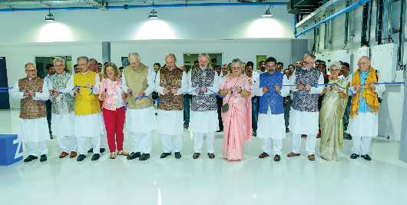 | From left to right: Gerhard Steinebrunner (V), Winfried Ebner (V), Prof. Dr.-Ing. Eberhard Abele (AR), Karin Stoll (Embassy), Gerhard Enders, Reinhard Schnurr (MD), Wolfgang Weber (AR), Ruth Zahoransky-Gorenflo (AR), Arvind Chawla (MD), Sven Clever, Dr. Barbara Mayer (Rechtsanwältin), Ulrich Zahoransky (V)  V = Board of Directors ZAHORANSKY AG  AR = Supervisory Board ZAHORANSKY AG  MD = Management ZAHORANSKY Coimbatore
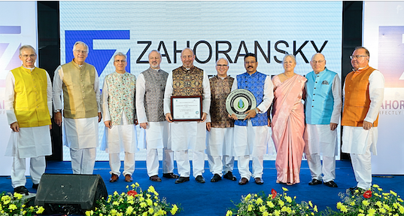 | The Supervisory Board (AR), the Board of Directors (V) ZAHORANSKY AG and the Management Board ZAHORANSKY Coimbatore (MD) received the "Platinum" award of the Indian Green Building Council (IGBC).  From left to right: Prof. Dr.-Ing. Eberhard Abele (AR), Gerhard Enders (AR), Winfried Ebner (V), Wolfgang Weber (AR), Reinhard Schnurr (MD), Gerhard Steinebrunner (V), Arvind Chawla (MD), Ruth Zahoransky-Gorenflo (AR), Ulrich Zahoransky (V), Uwe Joos (AR)
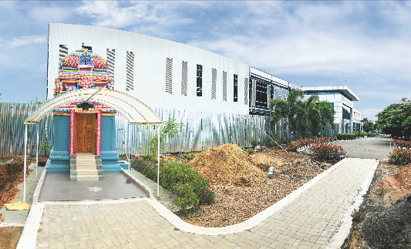 | With the extension of the plant in Coimbatore, India completed, ZAHORANSKY sets course for the sustainable expansion of its business in developing state-of-the-art solutions for toothbrush production in price-sensitive markets.

Further information:  ZAHORANSKY AG  Robert Dous, Head of Sales & Marketing  Anton-Zahoransky-Straße 1  79674 Todtnau-Geschwend  Tel.: +49 (0) 7671 997-0  Fax: +49 (0) 7671 997-299  E-Mail: robert.dous@zahoransky.com  www.zahoransky.com  https://www.facebook.com/ZAHORANSKYGroup/  https://twitter.com/_ZAHORANSKY_  https://www.youtube.com/user/ZAHORANSKYGROUP  https://www.linkedin.com/company/zahoransky-group/ | Public Relations:  Press'n'Relations GmbH  Nataša Forstner, Thomas Seibold  Magirusstr. 33, 89077 Ulm  Tel. +49 (0) 731 96287-17 bzw. 19  Fax +49 (0) 731 96287-97  E-Mail: nfo@press-n-relations.de,  ts@press-n-relations.de  www.press-n-relations.de

Background information
Since 1902, the ZAHORANSKY name has stood for reliability, precision, and sophisticated technology. The foundation of the company was laid by Anton Zahoransky, who produced the first devices and machines for automation and brush production in his small workshop in Todtnau.

Building on the experiences and skills gathered since then, ZAHORANSKY today operates as a full-service provider and technology partner for companies in the brush industry, medical technology, and additional industries. With injection-molding tools and mechanical engineering and automation technology, as well as packaging lines, ZAHORANSKY covers the full range of individual demands. This is what approx. 900 employees, of which 70 are trainees, work hard at every day at ten locations in Germany, Spain, China, India, Japan, Brazil, and the US.

The system-spanning ZAHORANSKY solutions cover the entire process chain: starting with the integration of packaging technology through handling up to the programming and robotics in the production of fully automated manufacturing and assembly lines. The ZAHORANSKY technologies and services are in high demand in the following industries: household and industrial brushes, oral care, medical technology, cosmetics, consumer goods, and packaging.

