Geislingen an der Steige, 15th July 2020

WMF SmartRemote
Self-service at its very best – contactless, hygienic and safe

The web-based app “WMF SmartRemote” is an innovative tool for ordering and preparing beverages completely contactlessly in the self-service segment. Created by the WMF Group, the coffee machine manufacturer from Geislingen, the app is easy and intuitive to use: scan the QR code with a mobile device, select a coffee speciality, take the beverage when it is ready, then relax and enjoy. Designed as a web-based application, the WMF SmartRemote solution is compatible with any mobile operating system (iOS, Android, Windows or Linux). There is no need to download and install a specific app. The only technology users need is a mobile device camera and a connected Internet browser. The solution is now available for all connected fully automatic coffee machines in self-service operation. Registered WMF CoffeeConnect users benefit from the continuous and ongoing development of the coffee machine software and therefore also from the activation of effective IT-based features like the new WMF SmartRemote solution.

Due to the current pandemic, restaurateurs in every sector are having to adopt new approaches to ensure that their coffee machines can operate both hygienically and cost-effectively. With its new WMF SmartRemote solution, the premium manufacturer is now offering an innovative method for contactless ordering and preparation of coffee specialities. This is how it works: customers use a smartphone or tablet to scan the QR code on the machine display. At this point, the WMF SmartRemote solution opens automatically on the customer’s mobile device. The secure, multi-browser-compatible HTML5-based web application lists all available coffee specialities in an intuitive display. Having chosen a beverage, the customer places the appropriate cup (or their own cup) underneath the machine spout and selects the product by tapping it on their mobile device. Once the relevant data has been successfully transferred to the coffee machine via WebSocket, the web app closes automatically and the machine dispenses the required beverage. After the order has been completed, the QR code is automatically regenerated so that the next customer can place a contactless order. The machine can of course also continue to be operated in the usual way via the machine display. Simply touch the screen and the QR code will disappear. “Our new WMF SmartRemote solution is enabling restaurateurs, hoteliers and shop owners to continue to deliver their self-service concepts in a way that is hygienic, clean and safe. With relatively little investment, coffee businesses can get back to what they do best. This solution is a positive and compliant tool which demonstrates our commitment to the safety of our customers and their guests,” says Eva Gold, Senior Manager Global Brand & Communications at GBU Professional Coffee Machines in the WMF Group.

The result: coffee indulgence without restrictions.
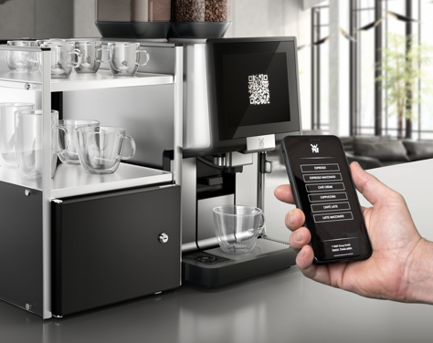
Watch this video to find out more.

Image request
You can find images on our media portal http://press-n-relations.amid-pr.com (search term “WMF-SmartRemote”).
Further information:  WMF Group GmbH  Eva Gold  Senior Manager Global Brand & Communications  GBU Professional Coffee Machines  Eberhardstraße 35 – 73312 Geislingen, Germany  Tel.: +49 73 31 25 8589  EGold@wmf.com - www.wmf.com | Press and public relations:  WMF Pressebüro  c/o Press’n’Relations GmbH  Monika Nyendick  Magirusstraße 33 – 89077 Ulm, Germany  Tel.: +49 731 96287-30  wmf@press-n-relations.de  www.press-n-relations.de

About the WMF Group
For over 160 years, WMF has been dedicated to achieving the perfect balance of design, functionality and quality. The company, based in southern Germany, is a global market leader in the Professional Coffee Machines (PCM) sector. With the aim of being the first choice worldwide for professional coffee solutions, the “made in Germany” quality seal combines premium products and innovative strength with peak performance and reliability.

At the core of the WMF PCM solutions portfolio is a clear message: Designed to Perform. The business unit from Geislingen an der Steige has just the right concept for every business model in the coffee sector – from high-performance fully automatic machines for coffee specialities and filter machines right through to fully automatic portafilters and innovative digitalisation concepts. Moreover, national and international customers alike benefit from high-quality consulting and service, based on the largest in-house service organisation for professional coffee machines in Europe. Regular training courses in the WMF training centres ensure that this expertise is continuously passed on to the entire global WMF service network.

At the end of 2016, WMF Group became part of the French Groupe SEB consortium. In this context, all B2B brands of the Group were recently brought together under the umbrella “SEB PROFESSIONAL”. In addition to WMF PCM, the umbrella brand also includes Schaerer and Wilbur Curtis coffee machines as well as the business division Professional Hotel Equipment with the brands WMF Professional and HEPP.

