Press release

Birkenfeld, 4 February 2019

Internorga 2019, 15 to 19 March, Messe Hamburg – Hall B7, Stand 411

A thousand ways to fascinate
New “HEPP Elements” tabletop collection

With “HEPP Elements”, HEPP has created an extremely comprehensive and puristic tabletop range that adds a modern twist to the collection concept of the traditional brand. True to its motto “Industrial style meets elegance”, the unique design language creates an extraordinary liaison using a variety of materials, from stainless steel 18/10 and concrete to melamine, porcelain and glass. During the development stage, a great deal of focus was also given to functionality and versatility. The modular concept of the 27-piece collection opens up unlimited combination possibilities for serving lunch, dinner or a relaxing coffee.
HEPP Elements is one of the highlights at the Internorga 2019, which is staged particularly effectively by the new exhibition stand concept. The redesigned stand design takes up the brand philosophy "The Art of Service" in a targeted manner and places intensive emphasis on the core topics of fine dining, buffet and cutlery.

Dare to be extraordinary
Restaurateurs and hoteliers that are looking for distinct unique selling points will find everything they need with HEPP Elements. The compelling look and the individual mix of materials are ideal for bold catering concepts that stand out from the crowd. The style language of the extensive tabletop collection transfers both the design and function of HEPP’s successful “Sequence” buffet concept to the laid table. Therefore, the two series can be combined together freely or each take centre stage when used on their own. In any case, guests will be impressed by the overall look that deviates from the familiar shapes yet harmonises with them.

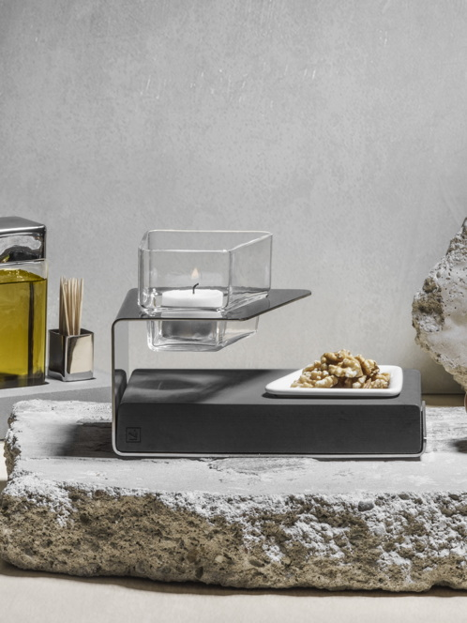
www.hepp.de

Image request
Images are available for downloading from our media portal http://press-n-relations.amid-pr.com. Simply by searching for the term „HEPP-Elements-2019“.

Further information:  proHeq GmbH  HEPP  Carl-Benz-Str. 10  75217 Birkenfeld  Tel. +49 7231 4885 0  Fax +49 7231 4885 83  hepp@press-n-relations.de  www.hepp.de | Press and public relations:  Press’n’Relations GmbH  Monika Nyendick  Magirusstraße 33 – D-89077 Ulm  Tel. +49 731 96287-30  Fax +49 731 96287-97  hepp@press-n-relations.de  www.press-n-relations.de

About HEPP
HEPP – Professional Hotel Equipment, proHeq GmbH – with its headquarters in Birkenfeld near Pforzheim, is one of the world’s leading suppliers for the perfectly laid table. The company
manufactures the broadest range of tableware and serving pieces anywhere in the world using highly specialised production techniques – from coffee pots and chafing dishes to food distribution systems. The focus is on the materials and processing, but HEPP products also meet the highest of requirements in terms of design, quality and usability. It was with this in mind that the company was first founded in 1863 by brothers Carl and Otto Hepp, who can rightly be considered the inventors of hotel silverware. Traditional values such as reliability and quality are just as important today and form the basis for the success of the company alongside innovation, the development of new techniques and products and flexible production. HEPP is one of the world’s major suppliers of leading hotels, hotel chains and restaurants, as well as quality-conscious bulk caterers, international cruise ship operators, airlines and railway companies. Since late 2016, HEPP – Professional Hotel Equipment, proHeq GmbH has belonged to the French company Groupe SEB.

